**Assignment 7**

**Objective** – Power BI Desktop, Cloud Service and End to End Workflow

**Use Case** – Import list of the Car Sale’s Data

**Source** – CarSales_TablesNew

**Analytics** – Generating data as per the requirement

**Report/Dashboard** – Car Sales

**Load data**

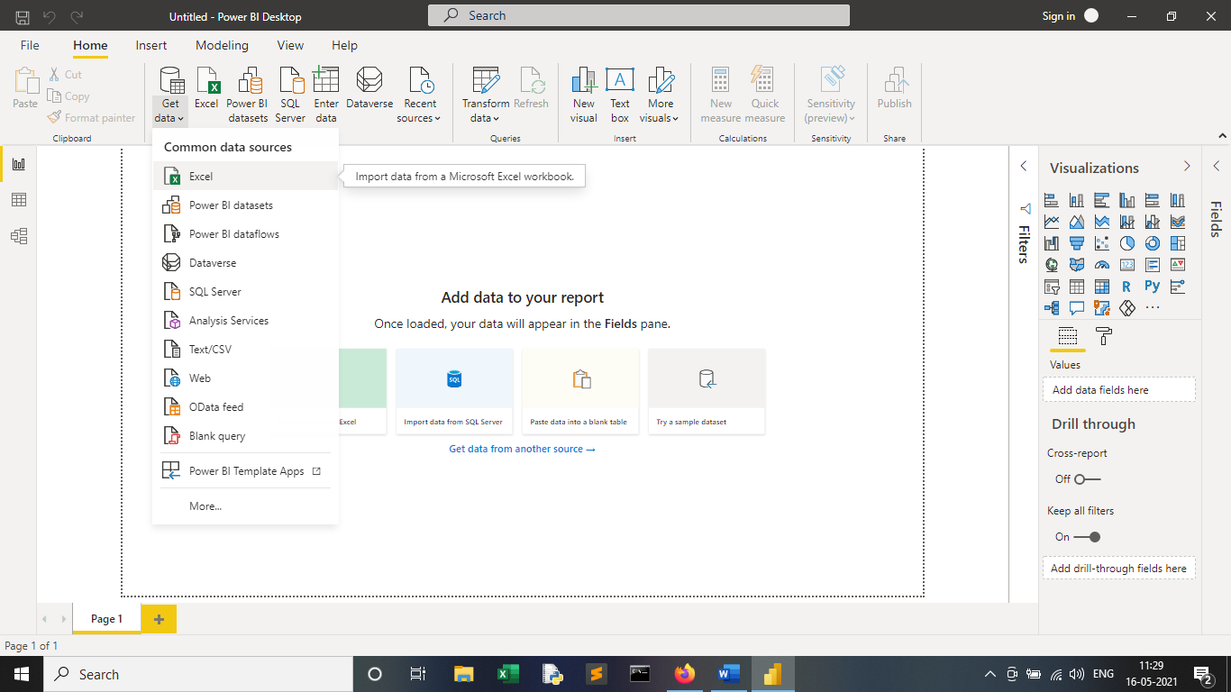

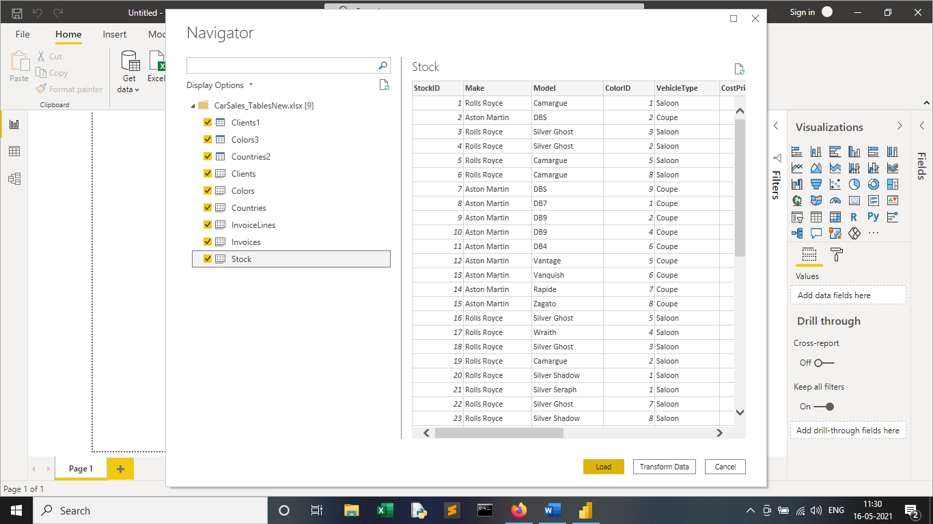

**Create a new Date Table using DAX**

Go to Modelling tab -- Create table and then write the following DAX formula Copy

Date table = CALENDAR ("01-01-2012","31-12-2015")

For better understanding the business we can extract some more information from the Date_table like

Year = YEAR('Date table'[Date])

MonthNum = MONTH('Date table'[Date])

MonthFull = FORMAT('Date table'[Date],"MMMM")

MonthAbbr = FORMAT('Date table'[Date],"MMM")

QuarterNo = QUARTER('Date table'[Date])

QuarterFull = FORMAT('Date table'[Date],"\Quarter q")

QuarterAbbr = FORMAT('Date table'[Date],"\Qq")

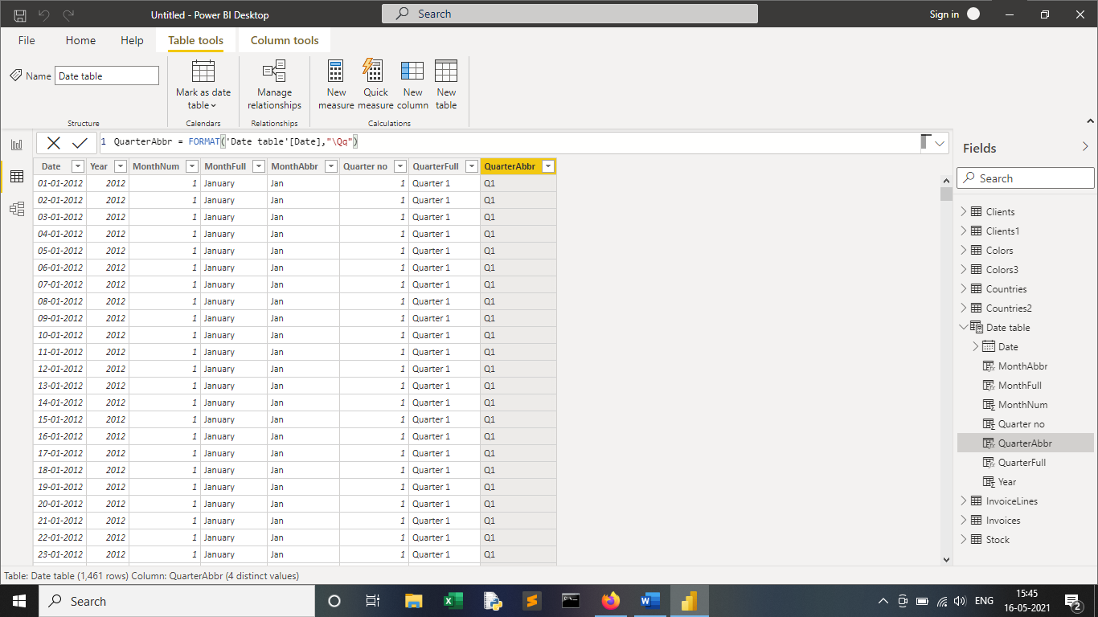

**Create a new measure to find the quarterly sales**

Click on New measure then apply the following

Quarterly Sales = TOTALQTD(SUM(InvoiceLines[SalePrice]),'Date table'[Date])

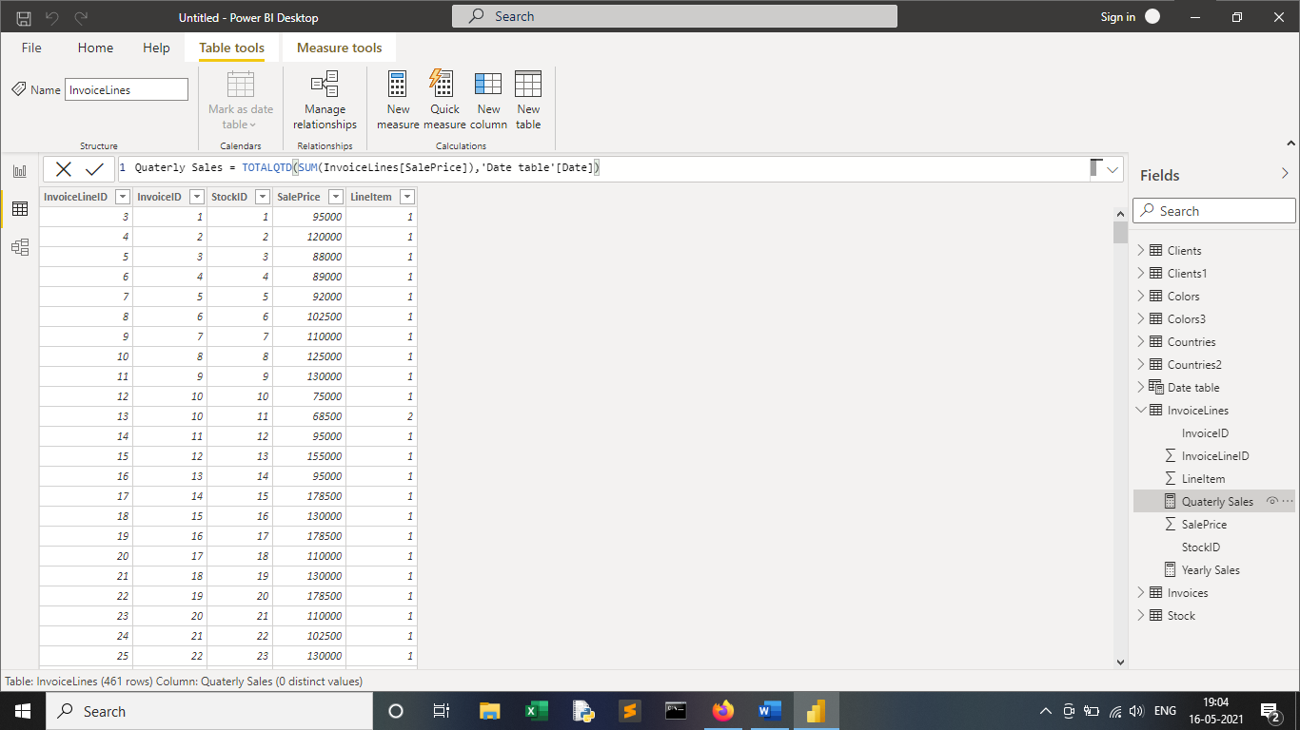

**Create a new measure to find the yearly sales**

Yearly Sales = TOTALYTD(SUM(InvoiceLines[SalePrice]),'Date table'[Date])

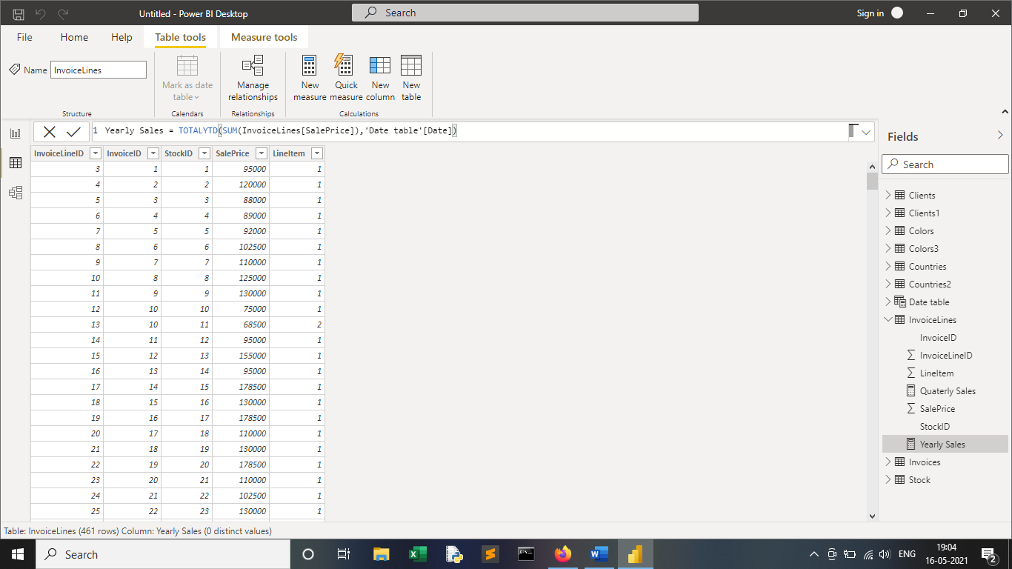

**The result is as followed:**

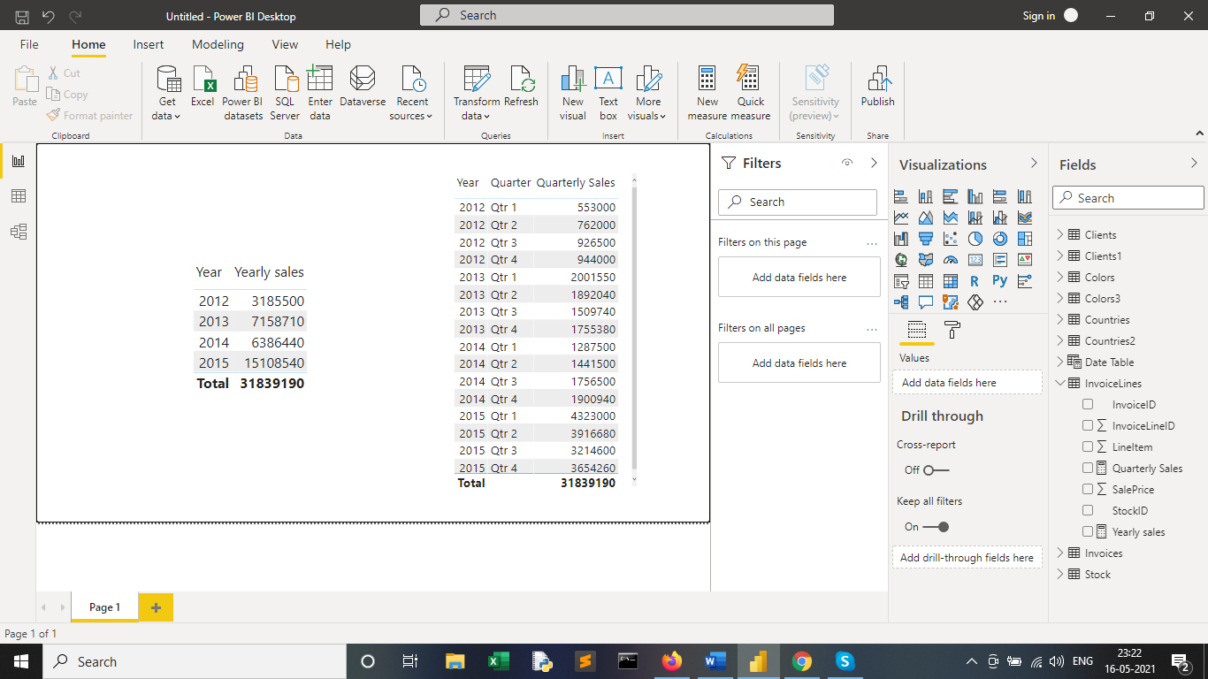

**Create a new table called Fact_Sales containing the data as follows**

Now create a new **Fact table** as per the requirements mentioned in the assignment using the below formula

**Fact Sales Table** = SELECTCOLUMNS(InvoiceLines,"SalePrice",InvoiceLines[SalePrice],"CostPrice",RELATED(Stock[CostPrice]),"spareparts",RELATED(Stock[SpareParts]),"LabourPrice",RELATED(Stock[LaborCost]),"Invoicedate",RELATED(Invoices[InvoiceDate]))

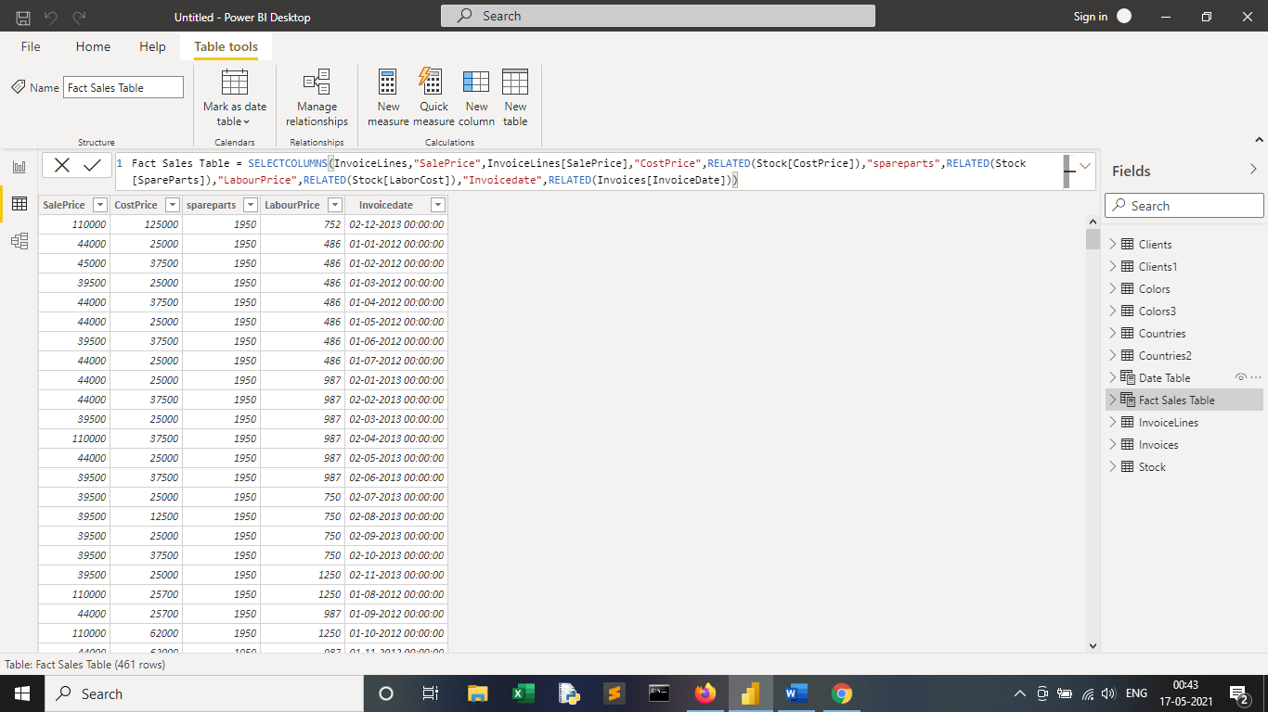

**TotalCost** = 'Fact Sales Table'[CostPrice] - 'Fact Sales Table'[spareparts] - 'Fact Sales Table'[LabourPrice]

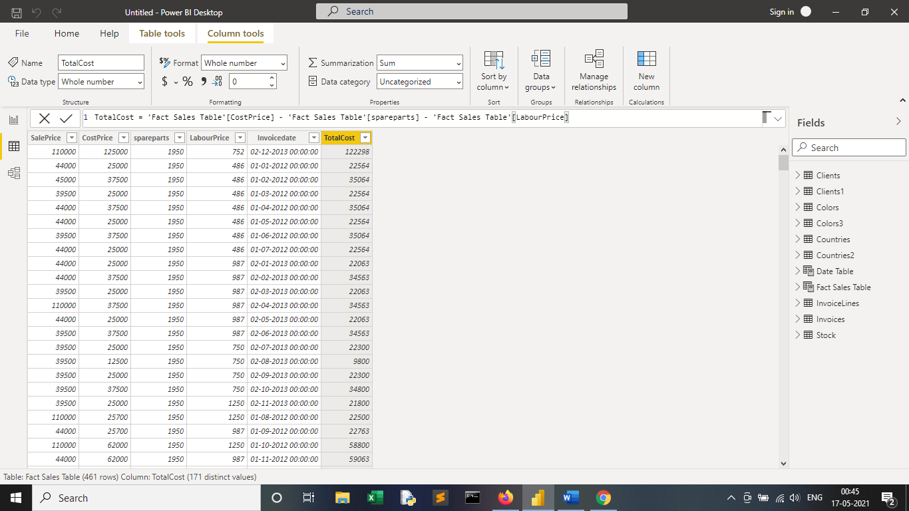

**Make manual connections in the data model wherever required**

The Model View will look as below

